

**Power Electronics and Electrical Machines Application in Electrical Mobility and Industrial Application**

**Deliverable 1: Mechatronics calculations**

**Authors:** Javier Muñoz, Marc Solagran

**Professor:**  Daniel Hereredo

**Date:** December 2023







**Index**

**1. Introduction 2**

**2. Activity 1 (Rotation Basic example) 2**

Drawing the required profile Kinematics: 2

Resulting ratios considering safety margin: 3

Kinematics and Dynamics required of the servomotor: 4

Overload level from the 600s burst: 5

Braking with the servomotor: 6

Conclusion: 7

**3. Activity 2 8**

Resulting ratios considering 20% safety margin: 9

Kinematics required by the motor: 9

Braking with the servomotor: 10

# 

# Introduction

This document corresponds to the first deliverable of the Power Electronics and Electrical Machines Application in Electrical Mobility and Industrial Application course. The primary objective is to develop a straightforward tool for analysing motor selection in industrial applications. For this purpose, an Excel file has been crafted. Two distinct cases are studied, each featuring different speed profiles and mechanical coupling elements like gear reducers, cylinder loads, and pinion racks.

The Excel files are used to obtain the kinematics and dynamics at both the input and output of each element, including the motors. Comparing these values to the datasheet ones allows a simple analysis of the suitability of the proposed motor for the application.

# Activity 1 (Rotation Basic example)

Simple rotation of a cylinder load with a R88M-KH1K520(F/C)-E from Omron G5 High inertia family motor.

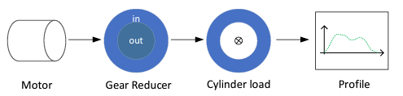  
***Figure 2.1****. Schematic of activity 1*.

### Drawing the required profile Kinematics:

Following the description from the exercise statement, we calculate a top angular speed and top acceleration values for our symmetric trapezoidal reference with a dwell time of 5 seconds. (figure 2.2)

  
***Figure 2.2****. Calculated profile max speed and accelerations*.

With those two values, constructing all three position velocity and acceleration profiles is trivial.

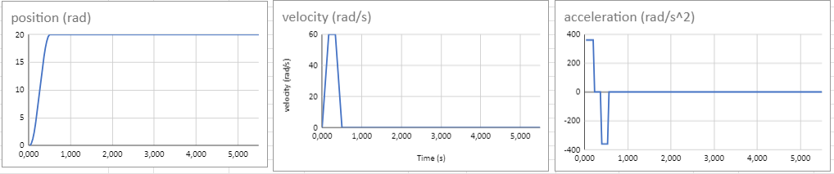  
***Figure 2.3****. Plots of position speed and acceleration profiles*.

### Resulting ratios considering safety margin:

Our profile requires a lot of torque from our servomotor and almost no speed.  
A safety design margin of 15% is being applied to all results as it is common in the industry to leave room for malicious real world tolerances and external factors to affect our theoretical model.

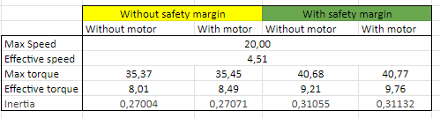  
***Figure 2.4****. Torque and speed requirements, max and RMS with 15% safety margin*.

The maximum inertia is very over the maximum values from the motor’s datasheet as well.  
This specific motor would be a very bad choice for our application as it is.

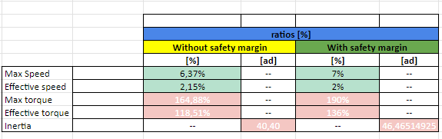  
***Figure 2.5****. Ratios of our model compared with the servomotor’s datasheet values.*

### Kinematics and Dynamics required of the servomotor:

Similar shapes to the profile kinematic plots, but notice how the gear transmission presence reduces all maximum values, maximum speed drops to 20 rad/s , rotor angular position drops as well from 20 to 6 rad, the same happens with acceleration.

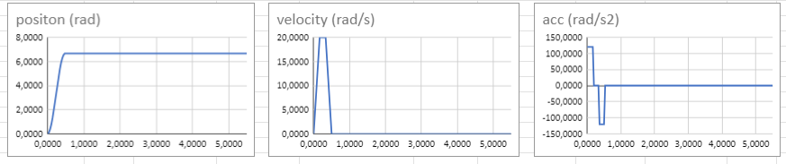  
***Figure 2.6****. Position speed and acceleration, Kinematics profiles as seen by the servomotor*.

The required torque, as expected, follows a similar shape to the acceleration, and with all inertias included tops around 35,45 [Nm], very far out of our motor specs. On the other hand, maximum required power would barely reach half of our motor’s rated power with 644W.

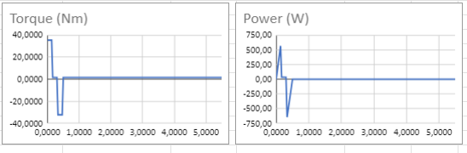  
***Figure 2.7****. Torque and Power , Dynamic profiles as seen by the servomotor*.

### Overload level from the 600s burst:

In order to test our motor temperature overload levels we are stressing our model to 109 consecutive trapezoidal profiles during 10 minutes followed by 15 minutes of dwell time.

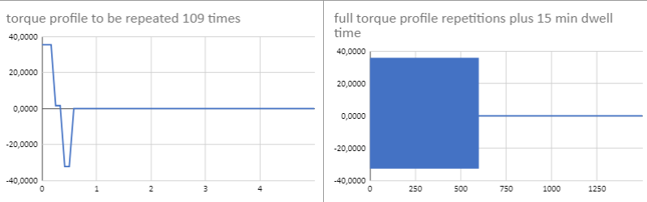

***Figure 2.8****. Detail of the torque profile and the full profile for our overload test*.

The temperature is calculated in pu units following the equation (figure 2.9)

  
***Figure 2.9****. Overload temperature equation.*

The test results reached a plateau with temperature overshoot of more than 2 times its safe level.  
Our chosen motor with our chosen speed profile would for sure overheat , resulting in a decrease of the lifespan guaranteed by the motors manufacturer or even catastrophic mechanical failure.

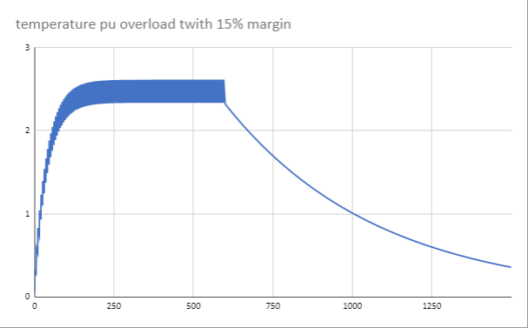  
***Figure 2.10****. Resulting Overload temperature in pu*

### Braking with the servomotor:

In order to test break capabilities of our model , we are assuming two different scenarios.  
One scenario where the servo motor brakes short circuiting its terminals, effectively relying only its own internal winding resistances, this gives us a braking time of 0,33seconds and 3,2rads of distance.  
In the next scenario, we are increasing the short circuit resistance 60 Ohms, this will decrease the short circuit current and its produced torque, resulting in a slower 0,44 seconds of braking time and 4.2 rads of distance.

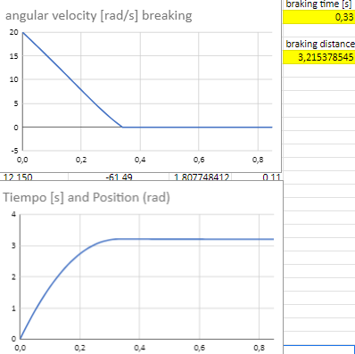  
***Figure 2.11****. Resulting Brake speed plots for short circuited motor.*

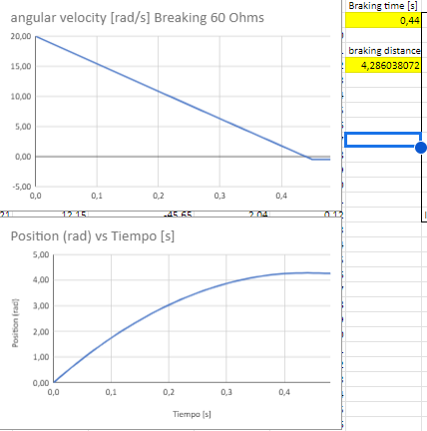

***Figure 2.12****. Resulting Brake speed plots for short circuited motor+ 60 ohms.*

### Conclusion:

Our system is demanding very low speeds from our motor but huge quantities of torque, way outside the motor maximum specs, the model we created proves this motor to be a **very bad choice for our application.**

The motor would be working way outside acceptable overload (temperature) values and the maximum inertia the system is applying to the motor shaft would be also >40 times larger than the datasheet limit

However, noticing that we are requiring low speeds and high torque from our motor, It would feel like the gear reducer’s input outputs are swapped, let's take a look at the model again with the **hypothetical Gear reducer’s Kp=1 / 3**.  
  
**All parameters would fit wonderfully**, speed requirements increase but within acceptable levels, torque is back to spec , inertia sits under the limit and overload temperature stays away from the 1 pu.

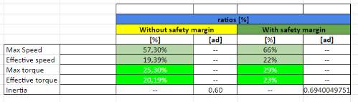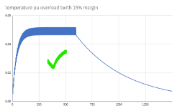  
***Figures 2.13 and 2.14****. Ratios and overload curve resulting from kp=0,33*

Braking time would also be reduced down to a mere 50ms, due to the system translating torque more effectively through the gear reducer.

# Activity 2

In this task the objective is to move a 100 kg mass linearly on an inclined plane. The mechanical coupling elements required are a pinion rack and a gear reducer. The desired speed profile is constituted by two symmetrical trapezoidal profile in speed, obtaining the following profiles:

| **Segment 1** | | | **Segment 2** | | |
| --- | --- | --- | --- | --- | --- |
| Increment of position | 0,05 | m | Increment of position | -0,2 | m |
| Time to position | 0,1 | s | Time to position | 0,25 | s |
| Dwell time | 0,2 | s | Dwell time | 0,1 | s |
| Max. speed | 0,75 | m/s | Max. speed | -1,2 | m/s |
| Max. acceleration | 22,5 | m/s2 | Max. acceleration | -14,4 | m/s2 |

**Table 3.1**.Main characteristics of the kinematics profile.

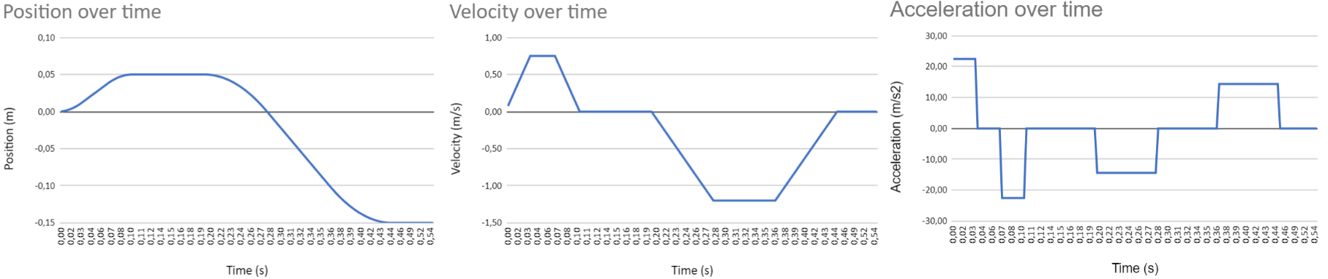

***Figure 3.1****. Kinematics profiles*.

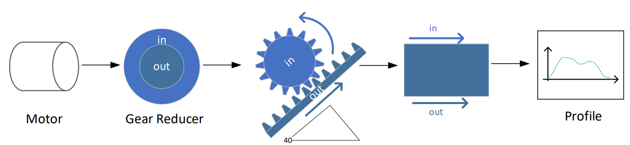

***Figure 3.2****. Schematic of activity 2*.

The fact that the plane is inclined introduces a force caused by the acceleration of gravity. This means that even when the acceleration is 0, the motor needs to provide torque to prevent the mass from moving downward. The equation that describes the movement of the object is the following, note that a frictionless plane is considered:

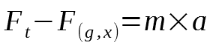

### Resulting ratios considering 20% safety margin:

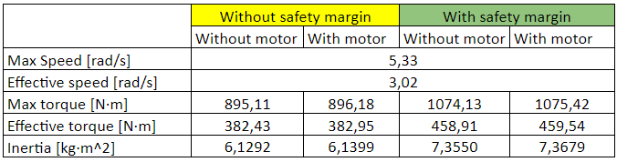

***Figure 3.3****. Torque and speed requirements, max and RMS with 20% safety margin*.

### Kinematics required by the motor:

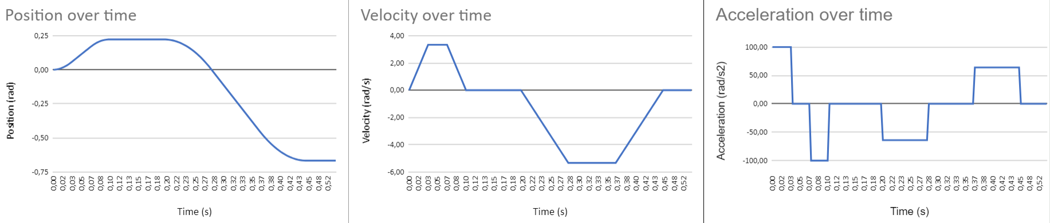

***Figure 3.4****. Position, speed and acceleration. Kinematics profiles as seen by the servomotor*.

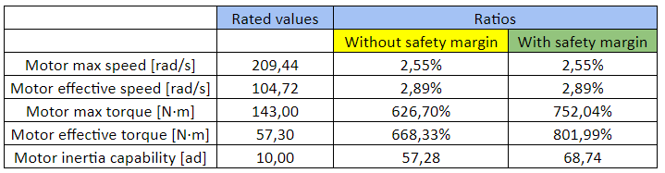

***Figure 3.5****. Ratios of our model compared with the servomotor’s datasheet values.*

Analysing Figure 3.5., we can conclude that the motor is not suitable for this application. Despite being a bit oversized in terms of power (Pmax= 3 kW while the rated power is 6 kW), it doesn’t meet the requirements, because the application requires high torque and very low speed. Thus, a less powerful very high torque servo motor would be more appropriate, and probably cheaper.

An obvious solution to make the motor more suitable for this application is to get rid of the gear reducer, which increases the torque and reduces the speed at the motor. In addition, this would improve the efficiency of the system since it has 5% of losses. In this case, the motor would still be not capable of delivering the desired values but is closer to it, as seen in **Figure 3.6.**

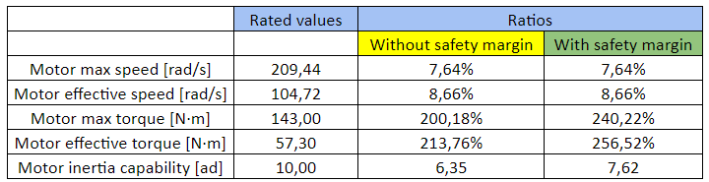

***Figure 3.6****. Ratios of our model without gear reducer compared with the servomotor’s datasheet values.*

### Braking with the servomotor:

Considering the initial speed as the maximum speed, if the braking is carried out by short-circuiting the motor terminals, it stops rotating after 0,11 s and suffers an increment of position of 0,282 rad during this time. This means that the load mass would advance 20,67 mm during the braking process. This is remarkable since this time is higher than the one third of the symmetrical trapezoid meaning that in the braking mode would actually brake slower. That’s due to in this case the power is dissipated, while in the normal operation mode the motor can act as a generator and absorb more power. This might also be explained by the fact that what we’ve considered the normal operation is not possible with this motor as seen previously.

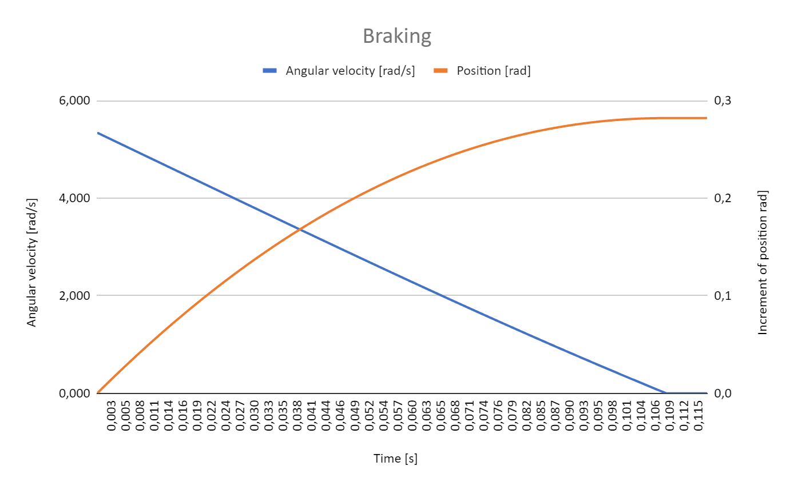

***Figure 3.7****. Speed and position plots for braking via short-circuiting the motor.*